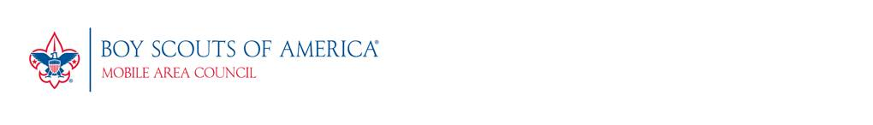
Letter of Intent
The Mobile Area Council, Boy Scouts of America, concerned with perpetuating Scouting for future generations of young people, has created a unique program called the Scouting Heritage Society, whose purpose is to recognize those special friends who have made a commitment of at least $1,000 to the Endowment Fund, either through planned giving or an outright gift. Those making a gift to the Endowment become lifetime members of the Scouting Heritage Society.

It is our intention, unless directed otherwise to place your gift into our Endowment Fund where it will be held in perpetuity. Only the income from the fund will be used for the general purposes of the Scouting Program.

Please help us by completing the following (all information will be confidential and no way legally binding):

I would like to become a Member of the Scouting Heritage Society by making the following type of gift to the Council’s Endowment Fund:

- A gift of Cash | - A gift of Stock | - A Bequest in My Will
- A gift of Life Insurance | - A Pooled Income Gift | - A gift of Real Estate
- A Charitable Gift Annuity | - A Charitable Remainder Trust | - Other
- I have not made any provisions or plans, but please send me more information

Description, purpose, amount, or comments related to the above: ___________________________
_______________________________________________________________________________
_______________________________________________________________________________
_______________________________________________________________________________

Please include a copy of any documentation establishing your gift. (optional)

Name(s): ______________________________________________ Phone: ___________________

Address:

City: State: Zip:

Executor or Secondary Contact: ____________________________ Phone: ___________________

IT IS FULLY UNDERSTOOD THAT COMPLETION OF THIS LETTER OF INTENTION IS NOT A LEGAL OBLIGATION ON MY PART AND MAY BE CHANGED AT ANY TIME WITHOUT NOTICE.

Signature: Date:

